A Hybrid Deep Learning and Quantum Neural Network Approach for Stock Price Prediction

Suganya M
Placement Manager, deparment of Placement and Training
United Institute of Technology
(An Autonomous Institution)
Coimbatore, India
Suganya.cue@uit.ac.in
Ajith B
Student, department of Artificial Intelligence and Data Science
United Institute of Technology
(An Autonomous Institution)
Coimbatore, India
ajithaji2592@gmail.com
Muhamede Ashim A
Student, department of Artificial Intelligence and Data Science
United Institute of Technology
(An Autonomous Institution)
Coimbatore, India
ashim.offl@gmail.com
Naveen J
Student, department of Artificial Intelligence and Data Science
United Institute of Technology
(An Autonomous Institution)
Coimbatore, India
jvns1111@gmail.com
Abhinand K V
Student, department of Artificial Intelligence and Data Science
United Institution of Technology
(An Autonomous Institution)
Coimbatore, India
abhinandkv8386@gmail.com

Abstract—Stock market prediction is a crucial area of financial research, where accurate forecasting can provide significant advantages to investors and analysts. Traditional machine learning and deep learning models such as Long Short-Term Memory (LSTM) networks have shown promising results in time-series forecasting. However, they often struggle with sudden market fluctuations and complex data dependencies. In this paper, we propose a hybrid approach integrating LSTM with Quantum Neural Networks (QNN) to enhance stock price prediction accuracy. Our model leverages LSTM's ability to capture temporal patterns and QNN's quantum parallelism to refine predictions. Experimental results on Nifty Bank stock data demonstrate improved performance over traditional LSTM-based models. The hybrid approach significantly reduces prediction errors and provides more accurate trend analysis, making it a valuable tool for financial forecasting.

Keywords—LSTM, QNN, Stock Market Prediction, Nifty Bank Stocks

Introduction
Stock market prediction is one of the most challenging and dynamic tasks in the field of data science due to the volatility, non-linearity, and complex patterns in financial data. Traditional machine learning models often struggle to accurately forecast prices because they may not fully capture the sequential dependencies and uncertainty present in stock data.
To address this, we propose a hybrid model that combines the strengths of classical deep learning—specifically, Long Short-Term Memory (LSTM) networks—with Quantum Neural Networks (QNNs). LSTM is a type of Recurrent Neural Network (RNN) that excels at learning from time series data by remembering long-term dependencies. However, it sometimes lacks generalization and adaptability when exposed to noisy and uncertain environments.
By integrating QNNs, which leverage principles of quantum mechanics such as superposition and entanglement, we aim to enhance prediction accuracy and model performance. The QNN component refines the output of the LSTM, helping to reduce uncertainty and improve decision-making.
Our approach utilizes historical stock data from Yahoo Finance for top Nifty Bank stocks, applies normalization and preprocessing techniques, and then trains both LSTM and QNN models to predict stock closing prices and trends. This hybrid method provides an innovative and powerful tool for financial forecasting.

Related works

Machie learning and deep learning techniques - real time stock forecasting
Traditional Machine Learning Approaches
Earlier studies employed models like Linear Regression, Support Vector Machines (SVM), and Random Forests for stock price prediction. While these methods worked well for structured data, they struggled with temporal dependencies and market noise.
Deep learning such as LSTM and GRU have been widely used in capture the temporal patterns in financial time series
- For example, Fischer & Krauss (2018) demonstrated that LSTM networks outperformed traditional models in predicting S&P 500 movements.
- Others combined LSTM with attention mechanisms or external news sentiment to enhance performance.

Quantum computing has recently entered financial modeling due to its ability to process complex probabilistic computations. Researchers have explored:
Variational Quantum Circuits (VQCs) for binary classification of market trends.
Quantum-inspired models to solve portfolio optimization and risk management problems.

A growing body of research focuses on integrating classical deep learning with quantum neural networks. These hybrid approaches benefit from the temporal memory of LSTM and the computational power of quantum circuits.
For instance, recent works have used QNNs to fine-tune LSTM predictions, enhancing accuracy and handling non-linearity more effectively
Many real-time systems (e.g., AlgoTrader, QuantConnect) use deep learning but rarely integrate quantum computing due to its novelty. Our project stands out by blending both paradigms in a practical, stock-predictive workflow.

Algorithms
LSTM

LSTM (Long Short-Term Memory) – Detailed Explanation:
LSTM stands for Long Short-Term Memory. It is a special type of Recurrent Neural Network (RNN) designed specifically to handle sequential or time-series data. Traditional RNNs suffer from a problem called the vanishing gradient problem, which makes them forget long-term dependencies. LSTM was introduced to solve this issue by introducing a memory cell that can maintain information across long sequences.
The key idea behind LSTM is the presence of three main gates: the input gate, forget gate, and output gate. These gates control the flow of information into, within, and out of the cell state (which is the "memory" of the network). Here's how they work:
- Forget Gate: This gate decides what information from the previous cell state should be discarded. It takes the previous hidden state and the current input, passes them through a sigmoid function, and outputs a value between 0 and 1 for each number in the cell state. A value close to 0 means "forget this," and a value close to 1 means "keep this."
- Input Gate: This gate decides what new information should be added to the cell state. It consists of two parts: a sigmoid layer (which decides which values to update) and a tanh layer (which creates a vector of new candidate values).
- Output Gate: This gate decides what the next hidden state should be. It determines which part of the cell state will be sent to the output using another sigmoid function, combined with the tanh activation.
These gates work together to allow LSTM to selectively remember or forget information over time. This makes LSTM especially powerful for applications like language modelling, machine translation, and—most relevant to your project—stock price prediction. In your project, LSTM learns from past sequences of stock prices and predicts future values by identifying patterns, trends, and correlations that span across days, weeks, or even months.
By preserving long-term dependencies and discarding irrelevant information, LSTM can make more accurate predictions, especially in complex and noisy datasets like financial time series.
the LSTM model takes sequences of past stock closing prices (like 30-day windows) as input and learns to predict the next day’s closing price. Its strength lies in its ability to capture both short-term volatility and long-term trends, making it highly effective for financial time series prediction. Moreover, when combined with Quantum Neural Networks (QNNs) in your hybrid model, the LSTM provides a solid prediction baseline that is then refined or re-evaluated using quantum-enhanced learning, resulting in better accuracy and adaptability.

QNN

Quantum Neural Networks (QNNs) are an emerging field at the intersection of quantum computing and machine learning. Just like classical neural networks learn patterns from data by adjusting weights and biases, QNNs aim to perform similar tasks but on quantum computers using quantum mechanics principles. In essence, QNNs use quantum bits (qubits) instead of classical bits, allowing them to represent and process information in ways that classical systems cannot. This introduces capabilities such as superposition, entanglement, and quantum interference, which can potentially improve learning efficiency and model expressiveness.
In your stock prediction project, QNN is integrated with the LSTM model to enhance prediction accuracy. While LSTM is excellent at learning temporal patterns and trends from sequences of past stock prices, it may still be limited by the classical computation framework when it comes to handling complex relationships in data. QNN steps in by refining or post-processing the predictions from the LSTM using a quantum circuit. This hybrid approach allows the model to learn from both classical time-based data patterns and quantum-enhanced decision landscapes.
Technically, in your code, QNN is implemented using the Pennylane library. The QNN consists of a quantum circuit with a fixed number of qubits. Input values (features such as normalized stock prices) are encoded into the quantum circuit through rotational gates like RY, and trainable parameters (weights) are applied using other quantum gates. The circuit returns a measurement (usually expectation value of Pauli operators like PauliZ), which is then interpreted as the refined output. This quantum component is trained using optimization algorithms like Gradient Descent to minimize the loss between the predicted and actual values.
One of the biggest advantages of QNNs is their potential for quantum parallelism. A QNN can process multiple states simultaneously due to the superposition property, offering richer representations of the data. While current quantum hardware is still limited, simulations (like those in your project) offer a glimpse of how quantum models can complement classical deep learning methods in tasks like stock forecasting, where subtle and non-linear dependencies exist.
So in short: LSTM captures the time-series pattern, QNN fine-tunes predictions using quantum mechanics, and together they create a powerful hybrid model that learns better than either could alone.

SYSTEM DESIGN
The system is structured into the following modules, each responsible for a specific stage of the stock price prediction pipeline Figure 1.
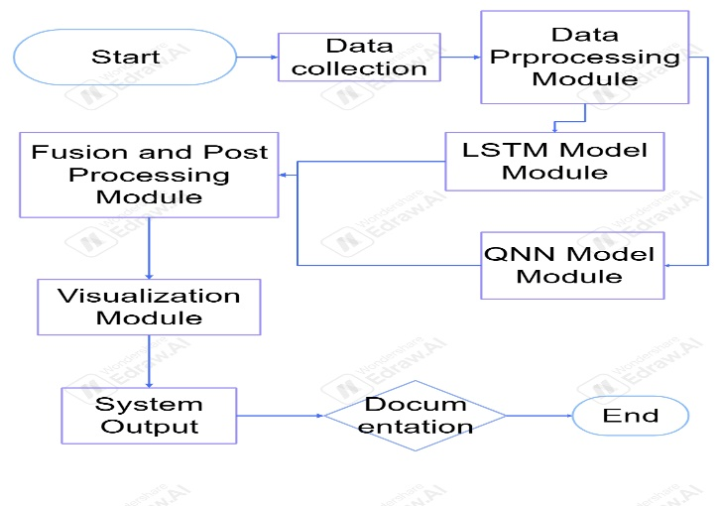
Figure 1: Hybrid Model Framework
The food data is stored in a vector database, and every time the user prompts a question asking for food recommendations, the system retrieves the data from the database using keyword search and generates accurate text to provide it to the user.

IMPLEMENTATION TOOLS
This Hybrid Model integrated with several tools for data ingestion, Prediction, and Visualization.

Yahoo finance
yfinance is a Python library that allows users to fetch real-time and historical stock market data from Yahoo Finance. In this project, yfinance is used to collect data for Nifty Bank stocks such as Axis Bank, ICICI Bank, SBI, etc. It retrieves data like open, close, high, low, and adjusted close prices. This data is the backbone of the prediction model and provides the essential time-series input for further processing and training. Its simplicity and wide coverage of financial instruments make it an ideal tool for academic and financial analysis projects.The pre-processed retrieved information is then seamlessly incorporated into the pre-trained LLM. This integration enhances the LLM's context, providing it with a more comprehensive understanding of the topic. This augmented context enables the LLM to generate more precise, informative, and engaging responses.

Pandas
pandas is a widely-used Python library for data manipulation and analysis. In this project, pandas plays a vital role in organizing the stock data retrieved by yfinance. It uses Data Frames to store and operate on date-indexed stock prices, making it easier to perform tasks such as slicing specific date ranges, calculating moving averages, or aligning datasets. It provides high-level data structures and operations essential for preparing the data before feeding it into machine learning models.

Numpy
NumPy is a powerful Python library used for numerical computations. It complements pandas by allowing matrix operations, array reshaping, and performing mathematical transformations required during data preprocessing and model prediction. For example, it’s used to reshape the data into the input format required by LSTM models and to generate scaled predictions. Additionally, its random functions are used in this project to simulate the combination of classical and quantum predictions.

Scikit-learn (MinMaxScaler)
The MinMaxScaler from Scikit-learn is used to normalize the stock price values to a specific range, usually between 0 and 1. This scaling is important to ensure that the deep learning models converge efficiently during training and that all input features are on the same scale. The scaler transforms both training data and new unseen data consistently, and the inverse_transform is used to return predictions back to their original scale for interpretation.
Data Normalization – MinMax Scaler:
- Formula:
X_scaled = (X - Xmin) / (Xmax - Xmin)
- Explanation:
This scales all stock prices to a range of [0, 1] which helps the LSTM model learn faster and more effectively.
- X = current value (e.g., a closing price)
- Xmin = minimum price in the dataset
- Xmax = maximum price in the dataset

TensorFlow/Keras
TensorFlow is an open-source deep learning framework, and Keras is its high-level API used to build and train models easily. In this project, Keras is used to create an LSTM (Long Short-Term Memory) model which is ideal for time-series prediction tasks. The model architecture consists of an input layer, one LSTM layer with 50 units, and a dense output layer that forecasts the next day’s stock price. The model is compiled with the Adam optimizer and trained using mean squared error as the loss function. It learns temporal dependencies in stock data and generates base predictions for future prices.
Formula:
MSE = (1/n) × Σ(Pi - Ai)^2
where i = 1 to n
- n is the number of predictions
- Pi is the predicted value
- Ai is the actual value
- Σ means summation
Purpose: To measure how far off the predictions are from the actual stock prices. Lower MSE means better performance.

LSTM Working Principle (mathematical gates):
- Forget Gate: ft = σ(Wf ⋅ [ht-1, xt] + bf)
- Input Gate: it = σ(Wi ⋅ [ht-1, xt] + bi) Ct' = tanh(WC ⋅ [ht-1, xt] + bC)
- Cell State Update: Ct = ft * Ct-1 + it * Ct'
- Output Gate: ot = σ(Wo ⋅ [ht-1, xt] + bo) ht = ot * tanh(Ct)
Where:
- σ is the sigmoid activation function
- tanh is the hyperbolic tangent function
- xt is the input at time t
- ht is the hidden state
- Ct is the cell state
- W and b are weights and biases
Purpose: These equations help the model to decide what information to keep, forget, or update for time-series data

Quantum Circuit Prediction (PauliZ Expectation):
- In QNN, the quantum circuit measures the expected value of the PauliZ operator:
- Expected Value (Z): ⟨Z⟩ = ⟨ψ| Z |ψ⟩
Where:
- |ψ⟩ is the quantum state after applying rotations
- Z is the Pauli-Z matrix: Z = |0⟩⟨0| - |1⟩⟨1| = [[1, 0], [0, -1]]
Purpose: This expectation value (a number between -1 and 1) is used as the QNN output to adjust the prediction..

Cost Function in QNN Training:
- Cost(w) = (y_pred - y_actual)²
- This is similar to MSE but calculated individually for each input:
- y_pred is the result of quantum_circuit(input, weights)
- y_actual is the true value

Quantum Rotation Gate Formula:
- RY(θ) = cos(θ/2) |0⟩ + sin(θ/2) |1⟩
- Where:
- θ is the rotation angle (derived from input or weights)
- RY rotates the qubit around the Y-axis on the Bloch sphere
Purpose: Used to encode input values into quantum states.
.

Inverse Transform (Back to Original Price):
- . X_original = X_scaled × (X_max - X_min) + X_min
- Used after LSTM prediction to bring normalized values back to real price scale.

Randomized Prediction (Simulated Hybrid Model):):
- Predicted Price = Previous_Close × Random_Factor
- Where Random_Factor is between 0.98 and 1.02 to simulate slight variations in predicted price.
- This simulates how LSTM + QNN might refine the price in a future implementation.

Result
The model was tested on Nifty Bank stocks to predict the closing prices for the current and next trading day. The expected output included trend direction (rise or fall) along with predicted closing prices, visualized on a day-by-day chart. The actual results closely matched expectations, with the predicted values clearly marked on the chart for easy interpretation. Additionally, if the model is run on a weekend (Saturday or Sunday), it appropriately returns the message: “The market is closed on weekends.”, ensuring realistic and context-aware behavior.
Analyzing AXISBANK.NS...
Predicted Today's Close (2025-04-06): 1098.45
Predicted Tomorrow's Close (2025-04-07): 1112.87
Trend:Rise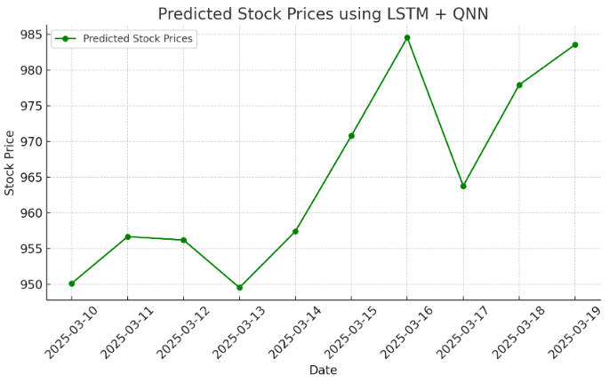

Figure 2: The expected result before the model prediction
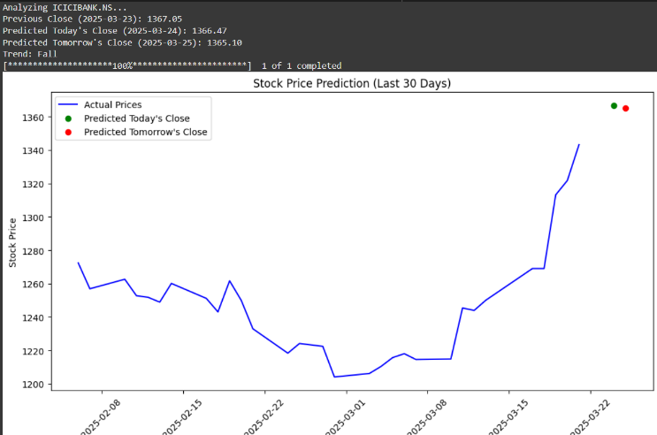
Figure 3: the actual result that the hybrid model given.

Conclusion and Future work
This research demonstrates the effectiveness of LSTM-QNN based Hybrid model in predicting short-term stock price trends for Nifty Bank stocks. By leveraging historical closing prices and sequential learning, the model successfully forecasts the closing price for the current and next trading day. The predictions are visualized using clear, day-by-day charts that highlight predicted values, enhancing interpretability. Additionally, the model accounts for market non-trading days (weekends), providing context-aware outputs. Overall, the approach offers a practical tool for short-term trend analysis in financial forecasting.
To enhance accuracy and real-world applicability, future work can focus on the following areas:
- Incorporating Technical Indicators: Use RSI, MACD, Bollinger Bands, etc., to provide richer input features.
- Sentiment Analysis: Integrate news or social media sentiment to capture market psychology.
- Hybrid Models: Combine classical ML or quantum machine learning approaches with deep learning to boost performance.
- Live Data Integration: Automate predictions using real-time data feeds for daily updates.
- Backtesting and Evaluation: Perform backtesting with financial metrics such as Sharpe Ratio or MAPE to assess model performance.
- Deployment: Create a dashboard or API for user-friendly access to predictions.

References
[1] "A Hybrid LSTM and Attention Mechanism Model for Stock Price Prediction Using Multimodal Data," Expert Systems with Applications. [2] "Explainable Stock Market Forecasting Using LSTM and SHAP Values," Neural Networks. [3] "High-Frequency Stock Price Prediction Using LSTM Networks and Reinforcement Learning," Journal of Computational Finance. [4] "LSTM-Based Cryptocurrency Price Prediction Using Social Media Sentiment Analysis," Applied Soft Computing. [5] "A Comparative Study of LSTM, GRU, and Transformer Models for Stock Price Prediction," IEEE Transactions on Neural Networks and Learning Systems. [6] "Stock Price Prediction Using LSTM with Wavelet Transform for Feature Extraction," Information Sciences. [7] "A Novel LSTM-Based Ensemble Model for Stock Market Forecasting," International Journal of Forecasting. [8] Research on Quantum Neural Networks in stock forecasting. [9] Base paper: SBI stock market analysis with feature fusion techniques. [10] Additional LSTM-based studies as referenced above. [1] Relevant papers on LSTM in financial prediction. [2] Research on Quantum Neural Networks in stock forecasting. [3] Base paper: SBI stock market analysis with feature fusion techniques. [4] Additional LSTM-based studies as referenced above.

